
WELCOME TO OUR SCHOOL

Enrolment
booklet
Nau mai, haere mai
We look forward to getting to know your child and your whānau. This booklet brings your enrolment details and permission forms together in one place.
Child’s full name | Enrolment / school year

How to complete this booklet
1. Fill in pages 2–7. Write clearly, or type into the shaded fields in Microsoft Word. Tick the boxes that apply. If a question does not apply, write “N/A”.
2. Read the cybersafety agreement with your child on page 8. Complete the separate permissions on pages 9 and 10, and sign each section where requested.
3. Return the completed forms to the school office. Page 11 is for staff. Keep this welcome page and the oral health information on page 12 for reference.

Have these ready
☐ Birth certificate or passport for verification
☐ Relevant court orders, if any
☐ Health, learning or support information you want us to know
If your child has attended another school, have its name and address ready. Ask the office if you need help or are unsure about a document.
Need a hand? Our school office can help you complete the forms. Please let us know if you would like to talk through any section.

Church Road, Kaitaia | 09 408 0228
kaitaiaps@xtra.co.nz | www.kaitaiaprimary.school.nz
02 / FAMILY INFORMATION

About your child
Please use the name shown on your child’s birth certificate or passport for their legal name.
Legal surname / family name | Legal first name(s)

Preferred surname / family name | Preferred first name

Date of birth (DD / MM / YYYY) | Gender | Place in family (e.g. 1st of 3)

Country of birth | Current class / year level (if known)

Home address

Rural emergency number (if applicable)

Home language(s)

Culture and identity
Please list up to three ethnicities, if applicable.
Ethnicity 1 | Ethnicity 2 | Ethnicity 3

Iwi | Hapū

Citizenship and residency
Is your child a New Zealand citizen or resident?
☐ Yes ☐ No ☐ Not sure
If no: date of entry to New Zealand (DD / MM / YYYY)

Residency / citizenship details or documents to discuss with the office

Eldest child currently at this school (name, if any)

03 / FAMILY INFORMATION

Whānau & contact details
Please tell us who to contact about your child. Let the office know whenever these details change.
Name(s) of legal guardian(s)

Parent / caregiver 1
Title | Legal surname / family name | First name(s)

Relationship to child | Country of birth

Home address (if different from child’s)

Mobile phone | Home phone | Work phone

Email address

Workplace & work hours | Occupation

Parent / caregiver 2
Title | Legal surname / family name | First name(s)

Relationship to child | Country of birth

Home address (if different from child’s)

Mobile phone | Home phone | Work phone

Email address

Workplace & work hours | Occupation

Emergency contacts
Please give two people we can contact if parents / caregivers cannot be reached.
Contact 1: full name | Relationship to child | Home phone | Mobile phone

Contact 2: full name | Relationship to child | Home phone | Mobile phone

04 / FAMILY INFORMATION

Before joining our school
This information helps us understand your child’s learning journey.

Previous school or centre
Previous school / centre name

Previous school / centre address

Early childhood education (ECE)
Did your child regularly attend ECE before starting school?
☐ Yes, regularly ☐ Occasionally / no regular schedule ☐ Did not attend
If regularly: number of years attended

Did your child attend an ECE service in the six months before starting school?
☐ Yes ☐ No
If yes, show the hours per week for up to three services in the table. Each column is one service. Leave unused columns blank.
Type of ECE service | Service 1  hours / week | Service 2  hours / week | Service 3  hours / week
Kōhanga Reo
Playcentre
Kindergarten or education and care centre
Home-based service
Playgroup
Correspondence School – Te Aho o Te Kura Pounamu

Only complete the following if you have not completed the ECE hours table.
☐ Attended, but only outside New Zealand
☐ Attended, but I do not know the type of service
☐ Did not attend
☐ Unable to establish whether my child attended

Other children in your whānau
List family members who are likely to enrol at this school in the future.
Name | Date of birth

05 / FAMILY INFORMATION

Health, wellbeing & learning
Please include anything that will help us care for your child and support their learning. Attach extra information if needed.
Doctor / medical practice | Doctor’s phone number

Dental clinic / oral health provider

Has your child had a B4 School Check?
☐ Yes ☐ No ☐ Not sure
B4 School Check: health information | B4 School Check: development information

B4 School Check: behaviour information

Vision: anything we should know? | Hearing: anything we should know?

I consent to my child’s vision and hearing being tested.
☐ Yes ☐ No
Allergies (including food requirements / medicine) | Medication

Speech / communication needs | Serious health problems

Learning / behaviour needs

Special needs, resourcing, support services or agencies involved

Other information or requests (attach extra pages if needed)

06 / FAMILY INFORMATION

Privacy & enrolment declaration
Please read this page before signing. Ask the school office if you have any questions.

How your information is used
The information collected will be used by the school for enrolment and forms an essential part of the information held by the school about your child. Records made from this information may be viewed on request at the school.
The information collected may be disclosed to appropriate education, health and welfare authorities and, for data-gathering purposes, to the New Zealand Ministry of Education, in accordance with the principles of the Privacy Act. It will not be disclosed to any other person or agency unless the disclosure is authorised or required by law.

Parent / caregiver declaration
By signing below, I confirm that I have read and accept the privacy statement above. I agree:
• The school may take action on my behalf in the case of sudden illness or injury.
• I will abide by the school’s policies.
• My child’s work and image may be used in accordance with the school’s online publishing policy / procedures and the school-promotion permission recorded on page 10.
• The school may forward my child’s name and address to a potential intermediate or secondary school.
• All the information I have provided is true and correct.
School promotion and media are covered separately on page 10. Please record your choice there and discuss any concerns with the office before signing this declaration.

Child’s full name

Parent / caregiver full name | Relationship to child

Parent / caregiver signature | Date (DD / MM / YYYY)

Custody & school-report copies
Is there a court order relating to your child?
☐ Yes ☐ No ☐ N/A
If yes, please attach the relevant information and discuss it with the office.
Extra copy of school report to: name | Postal / email address

Additional information / requests

07 / CONSENTS & AGREEMENTS

Cybersafety use agreement
Read this agreement together. Both the student and a parent / legal guardian / caregiver need to sign.

Our school’s responsibilities
Kaitaia Primary School will do its best to enhance learning through information and communication technology (ICT), including computers and devices. We will work to restrict access to inappropriate, illegal or harmful material on the internet and other school ICT equipment, at school and during school-related activities.
We will help children and families understand cybersafety through education and support, and give children strategies to keep themselves safe online. We will keep the signed agreement on file, respond appropriately to breaches and welcome questions from parents and students.

Student agreement
I have read this agreement carefully with my parent or caregiver. I understand my responsibilities and agree to:
• Follow cybersafety rules and instructions whenever I use school ICT, or privately owned ICT on the school site or at a school-related activity.
• Never use ICT in a way that could put me or other members of the school community at risk.
• Take proper care of computers and other school ICT equipment. If I am involved in damage, loss or theft of school ICT equipment / devices, my family may be responsible for repair or replacement costs.
• Ask my teacher or parent if I am unsure about anything in this agreement.
I understand that there may be serious consequences if I breach this agreement.
Student name | Class / room

Student signature | Date

Parent / legal guardian / caregiver agreement
I have read this agreement and understand the school’s efforts to maintain a cybersafe learning environment and the responsibilities involved. I will discuss the rules with my child, ensure we both sign and return the agreement, and support the school’s cybersafety programme.
I will encourage my child to follow the rules and ask their teacher if they are unsure about ICT use. I may contact the Principal or School Cybersafety Manager at any time to discuss this agreement or ask questions.
Parent / legal guardian / caregiver name | Relationship to child

Parent / legal guardian / caregiver signature | Date

08 / CONSENTS & AGREEMENTS

Local visits & special activities
Please read this permission carefully. It applies only to the school year recorded below.

What this permission covers
During the year, children may take part in local out-of-school visits or special activities at school. Examples include school sports trips, visits to community venues, walking-distance visits to the community centre, town pool or recycling centre, and special activities such as a water slide.
These events will be included in the school newsletter so you know about them. Any event involving significant travel and / or risk will have a separate permission form that must be signed before your child can participate.
The school must have signed permission on file. Verbal confirmation cannot be accepted. Without a signed permission form, your child cannot take part in these local visits or special activities.

Your permission
Child’s full name | Class / room

School year this permission applies to

Please tick one choice.
☐ I give permission ☐ I do not give permission
If I give permission, I authorise my child to participate in localised out-of-school activities or special activities planned by the school during the school year written above. I understand that without signed permission my child will be unable to participate.
Parent / caregiver full name

Parent / caregiver signature | Date (DD / MM / YYYY)

Information to discuss with the school
Any questions, relevant needs or information about participation

If you are unsure about a particular activity, contact the school office before completing this permission.
09 / CONSENTS & AGREEMENTS

School promotion & media
Please record your choice for the school year below. This permission is separate from activities permission.

How the school shares its learning
The school sometimes shares what is happening at school to celebrate children’s learning and maintain a positive public profile. The school newsletter is uploaded to the school Facebook page, along with other items about children and staff that are shared with the wider community.
School promotion may include the newsletter, Facebook, the school website, radio or television. This form covers the whole school year recorded below, so you do not need to sign a separate form for every promotional item.

Your child can still take part
If there is no signed permission form on file, staff will assume you want your child to remain anonymous in media items. Your child may still participate in the school activity, and the school will make every effort to ensure their anonymity.
If your decision changes, contact the school office. If an image of your child appears as part of a school promotional event and you want it removed, contact the office and it will be removed.
A “no” choice does not stop your child taking part in the school activity. It tells the school not to include your child in promotional media items.

Your choice
Child’s full name | Class / room

School year this permission applies to

Please tick one choice.
☐ I give permission ☐ I do not give permission
If I give permission, I authorise my child to participate in school promotion activities planned by the school during the school year written above, including the newsletter, Facebook, school website, radio or television.
Parent / caregiver full name

Parent / caregiver signature | Date (DD / MM / YYYY)

Any questions or privacy concerns to discuss with the office

10 / SCHOOL OFFICE

School office checklist
For school staff only. Families do not need to complete this page.
Child’s full name | School admission number

Birth / identity verification
☐ Birth certificate ☐ Passport
Birth certificate / passport number | Verified by / date

Records / information requested: date | Records / information received: date

Number of previous schools / enrolments | National Student Number (NSN)

Bus route | Date of entry | Year level

Teacher | Room

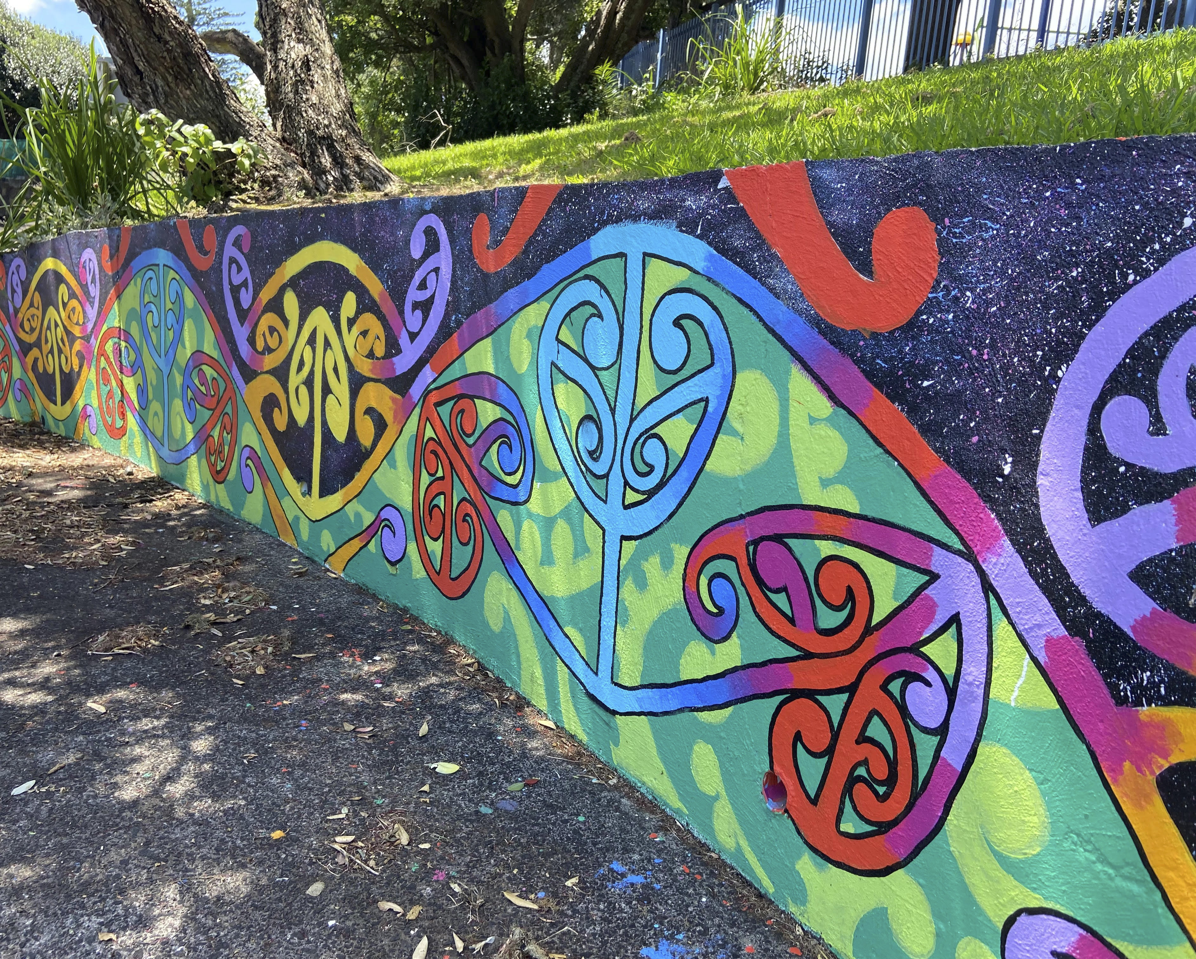

11 / CONSENTS & AGREEMENTS

Oral health enrolment & consent
Te Whatu Ora Te Tai Tokerau Oral Health Service | Birth to 18th birthday
Complete this section for the oral health service, even if you have supplied the same details elsewhere. Keep the treatment information on page 12.
Child / patient first name(s) | Surname

Date of birth (DD / MM / YYYY) | Sex: M / F | NHI number (if known)

Home address | Postcode

Contact name | Work phone

Alternative contact name | Alternative contact phone

Mobile phone | Email

Ethnicity (tick and specify where needed)
☐ NZ Māori ☐ NZ European ☐ Pacific Islander ☐ Other
Other ethnicity: please specify | Iwi | Hapū

School / educational facility | Doctor (GP) / practice name

What you are consenting to
By signing this enrolment form for you or your child, you agree to receive ongoing oral health care until the patient’s 18th birthday. This includes regular dental examinations, dental X-rays and preventive care when needed (including fluoride varnish and fissure sealants). These procedures will be explained fully before proceeding at each visit.
If further dental treatment is needed, you will be informed and asked for further consent before treatment begins.
Patient signature (if 16 years or older)

Parent / legal guardian signature

Print name of person giving consent | Relationship to patient (if applicable)

Date (DD / MM / YYYY)

You are encouraged to attend appointments with your child. If you have questions about enrolment or would like to attend an appointment, contact the dental team or call into the clinic.
12 / KEEP FOR REFERENCE

Oral health information
Keep this page for future reference. Information supplied in the current Te Whatu Ora Te Tai Tokerau Oral Health Service forms.
The enrolment consent on page 7 covers examinations, X-rays and preventive care. If further treatment is needed, the dental team will explain it and ask for further consent before it begins.
Fluoride varnish A fluoride paste applied to selected tooth surfaces to protect teeth with early signs of decay, or teeth that are particularly vulnerable to decay.
Fissure sealant A tooth-coloured coating applied to the chewing surfaces and sides of teeth that are at risk of decay. It is a simple procedure that does not require local anaesthetic. It contains fluoride to help protect teeth. A temporary pink sealant may be used on a partly erupted tooth and gradually wears away over about two years.
Glass ionomer cement (GIC) A tooth-coloured material used to help prevent decay and fill teeth, mostly baby teeth. It is usually not the preferred filling material for permanent adult teeth because it is not as strong as composite. It contains fluoride. A pink version may indicate a temporary filling that could need further treatment.
Composite fillings Strong, tooth-coloured fillings suitable for front and back permanent adult teeth. They contain a small amount of fluoride for extra protection.
Stainless steel crowns Pre-formed, tooth-shaped stainless steel crowns used to restore heavily decayed or heavily filled back baby teeth.
Local anaesthetic An injection into the gum that numbs the tooth and surrounding tissues so dental treatment can be carried out without pain.
Dental radiographs / X-rays Part of routine dental examinations. They help diagnose and detect early decay that cannot be seen by eye, and other issues such as missing or extra teeth.
Clean and scale Removal of stains and hard debris from tooth surfaces.
Pulpotomy A type of root canal treatment that is sometimes carried out on baby teeth.

Everyday care for healthy teeth
• Brush twice daily, after breakfast and before bedtime.
• Use a soft toothbrush and fluoridated toothpaste.
• Brush, spit, don’t rinse.
• Water is the best drink.
• Choose fresh fruit and vegetables for snacks.
You are encouraged to attend dental appointments with your child. For enrolment questions or appointment arrangements, contact the dental team or call into the clinic.

